
By Sarunas Surdokas
Crime, Disproportionality, and Policing: An Analysis of Stop and Search

Contents
Abstract 4
1. Introduction 5
2. Objectives 7
3. Methodology 8
3.1 Data and Pre-processing 8
3.2 Feature Engineering 9
3.3 Exploratory Data Analysis 12
3.4 Geographic variation 14
3.5 Statistical Testing 14
3.6 Predictive Modelling 17
4. Findings 17
4.1 Predictive Modelling Performance 17
4.2 Geographical Distribution of Stop-and-Search 18
4.3 Disproportionality and Ethnic Breakdown 19
4.4 Synthesis of Results 20
5. Discussion 20
5.1 Temporal Patterns in Policing 20
5.2 Outcomes by Ethnicity 21
5.3 Geographic Concentrations 22
5.4 Predictive Modelling and Data Limitations 22
5.5 Implications 23
6. Conclusion 23
References: 25
Appendix: 26

Figure 1: Monthly Street Crime Trend (Jan–May 2025) 10
Figure 2: Distribution of Top 12 Street Crime Types (Jan–May 2025) 11
Figure 3:Stop-and-Search Share per 100 Stops (by Ethnicity) 12
Figure 4:Stop-and-Search Rate per 1,000 by Ethnicity (excl. ‘Other’) 13
Figure 5: Stop-and-Search Outcomes by Ethnicity (Proportions) 13
Figure 6: Relative Stop-and-Search Rates by Ethnicity (vs White, 95% CI) 15
Figure 7: Outcome × Ethnicity — Standardised Residuals 16
Figure 8: ROC Curve for Logistic Regression Model (AUC = 0.62) 18
Figure 9: Geographic Heatmap of Stop-and-Search Activity (England and Wales) 19
Figure 10: Stop & Search Hourly Distribution by Day of Week (%) 21
Figure 11: Stop & Search Outcomes by Ethnicity (Proportions) 22

Abstract

This study analyses police data from January–May 2025 to examine (i) disparities in stop-and-search and arrests across ethnicity, age, and gender, (ii) spatio-temporal patterns of crime and enforcement (city/LSOA, month, weekday, hour), and (iii) the practical value and limits of predictive modelling for policing outcomes. We cleaned and harmonised three sources (outcomes, stop & search, street crime), standardised types and geocoding, removed duplicates, and created derived features (hour, weekday, month, broad ethnicity). To assess equity, we produced population-normalised rates using 2021 Census proportions; to assess deployment, we mapped hotspots and hour-by-weekday intensity; and to assess predictability, we trained a transparent logistic-regression baseline.
Findings show persistent disproportionality: minority groups—especially Black individuals—experience stop-and-search at rates several times higher than White individuals even after normalising by population, while “no further action” remains the most common outcome across all groups. Activity is highly concentrated in metropolitan areas (notably London) and peaks in the late afternoon/evening and at weekends, indicating structured deployment around anticipated demand. Predictive performance is modest (ROC AUC ≈ 0.62), suggesting limited utility of administrative features for forecasting outcomes.
We conclude that stop-and-search, as currently practised, is uneven and low-yield, raising concerns for fairness and legitimacy. Operationally, targeted visible presence at identified times/places combined with community-oriented engagement is preferable to increased stop intensity. Limitations include the observational design and feature constraints; no causal claims are made. An accompanying interactive map (hosted externally) supports reproducibility and stakeholder exploration.

1. Introduction
This study analyses police data from January–May 2025 to examine (i) patterns and disparities in stop and search and arrests across ethnicity, age, and gender; (ii) spatio-temporal dynamics of crime and enforcement (city/LSOA, month, weekday, hour); and (iii) the practical limits of simple predictive modelling for policing outcomes (baseline ROC ≈ 0.62). We harmonise three sources (outcomes, stop & search, and street crime), compute population-adjusted rates, map hotspots, and quantify outcome differences. The aim is to test whether long-standing concerns—disproportionality, limited crime-reduction benefits of certain tactics, and risks to legitimacy—remain visible in current data and to identify operational windows (where/when) for targeted, visible policing.
Concerns about disproportionality have deep roots. Lord Scarman noted that “Britain is an institutionally racist society” [1, p. 42], and official figures later reported that “Black people were, on average, five times more likely to be stopped and searched … and more likely to be arrested than white or other ethnic groups” [1, p. 360]. We therefore re-test contemporary stop-and-search and arrest disparities (Jan–May 2025) across ethnicity, age, and gender.
Recent government statistics show these gaps persist: 529,474 stops in 2022/23, 24.5 per 1,000 Black people vs 5.9 per 1,000 White people, and roughly one-third in the Metropolitan Police area [2]. We benchmark our 2025 window against these indicators, then drill down to force/city and LSOA granularity to compare local with national patterns.
Academic evidence reinforces the disparity. Shiner et al. report a 75% fall in usage (2010/11–2016/17), yet “Black people were stopped and searched at more than eight times the rate of white people,” with drug searches almost nine times as likely for Black people and lower ‘find’ rates than for White people [3, p. 6]. We reproduce outcome-by-ethnicity analyses and, where possible, stratify by offence category to assess whether hit rates in 2025 align with these concerns.
Effectiveness is contested. Bradford and Tiratelli describe stop and search as “one of the most controversial powers” with an effect on crime that is “at best marginal” [4, p. 1]. We do not attempt causal evaluation; instead, we triangulate descriptively: where stops/arrests change, do local crime counts fall or merely shift?
Public confidence and legitimacy have weakened. The College of Policing reports “victim satisfaction was the lowest in 20 years” [5, p. 9] and “trustworthiness dropping by ten percentage points” in the four years before 2023/24 [5, p. 10]. It recommends targeted visible presence in hot spots or places with low trust, coupled with engagement [5, p. 4]. We pair hotspot mapping with hour-by-weekday views to identify when targeted, visible policing could occur without over-reliance on contentious tactics.
Legitimacy shapes behaviour across the justice system. McCarthy & Brunton-Smith show that “prisoners who perceive their experience of prison as legitimate are more likely to believe that they will desist” [6, p. 1], and that trust/respect relate to more favourable desistance assessments that persist post-release [6, pp. 17–19]. When interpreting disparities and outcomes, we discuss how procedural fairness and legitimacy may affect cooperation and longer-term compliance—contextualising what descriptive statistics can and cannot say.
On deployment, Ratcliffe notes that “crime hotspots are becoming central to policing strategy … to focus resources into the areas of highest need” [7, p. 5], and that understanding spatial and temporal dynamics can limit both patrol area and time costs [7, pp. 18–19]. We operationalise this by building spatio-temporal views (month, weekday, hour × location), normalising by population, and surfacing actionable windows/places.
Finally, evidence on alternatives and harms informs our interpretation. A Campbell meta-analysis of 40 studies (90,904 individuals; 20,876 places) finds a 13% crime reduction from police-initiated pedestrian stops, but a 46% increase in odds of a mental-health issue and 36% in physical-health issues, plus worsened attitudes toward police; overall, “the totality of evidence makes it difficult to recommend” such tactics over alternatives [8, p. 2]. By contrast, Gill et al. “identified 25 reports containing 65 tests” of community-orientated policing and found positive effects on satisfaction, perceived disorder, and legitimacy, but limited effects on crime/fear [9, p. 2], urging clearer links from short-term perceptual gains to longer-term prevention [9, p. 3].
Contributions and boundaries. We contribute (1) a recent, harmonised view (Jan–May 2025) combining outcomes, stop & search, and street crime; (2) population-normalised disparity metrics; (3) spatio-temporal hotspot windows for operational planning; and (4) a transparent baseline model (ROC ≈ 0.62) that clarifies the limits of prediction using administrative features. This is an observational study: we make no causal claims, and we treat fairness carefully (e.g., excluding ethnicity from predictive features and assessing disparities separately).

2. Objectives
The aim of this project is to examine contemporary patterns of policing in England and Wales using publicly available police data covering January to May 2025. Building on longstanding debates around fairness, legitimacy, and effectiveness, the project seeks to explore how crime and police practices manifest across time, space, and demographic groups.
First, the study sets out to assess racial and demographic disparities in stop and search practices. Prior research has consistently highlighted disproportionate targeting of minority ethnic groups, yet questions remain over whether these patterns persist in recent years. By analysing outcomes by ethnicity, age, and gender, the project tests the degree to which disproportionality continues to shape stop and search results.
Second, the project aims to examine temporal crime and enforcement trends. This involves analysing daily, weekly, and hourly patterns to identify when crime and stop and search incidents are most likely to occur. Such temporal mapping provides insight into high-risk periods and whether patterns vary by day of the week or time of day.
Third, the study will explore the spatial concentration of crime and enforcement activity. By mapping street crimes and stop and searches geographically, the project highlights hotspots and areas of concentrated activity. This spatial analysis not only identifies the uneven distribution of crime but also raises questions about how resources are allocated and whether policing intensity matches community need.
Fourth, the analysis seeks to evaluate the effectiveness of enforcement outcomes. Specifically, it examines the proportion of stop and searches that lead to arrests or other formal actions, and whether effectiveness varies across demographic groups. This offers an important measure of whether policing tactics achieve their intended objectives.
Finally, the project aims to relate these patterns to wider issues of trust and legitimacy. The findings are interpreted in light of existing concerns around institutional racism, community relations, and the balance between deterrence and public confidence. By connecting statistical outcomes to broader debates, the project situates quantitative evidence within its social and policy context.
Together, these objectives provide a structured framework for the analysis, ensuring that the study addresses not only descriptive patterns in the data but also their broader implications for equity, efficiency, and public legitimacy in contemporary policing.

3. Methodology

3.1 Data and Pre-processing

Data source.
All analyses rely on a single primary source: the UK Police open data for Jan–May 2025. Three tables are used throughout: (i) Outcomes (case outcomes associated with street crime), (ii) Stop & Search, and (iii) Street-level crime. Files were ingested in CSV format and treated as separate but linkable event datasets.
To enable meaningful comparison across areas, crime counts were normalised to population denominators, producing a crime rate per 100,000 residents. The general formula is expressed below:
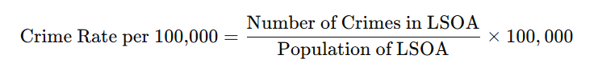
Scope and identifiers.
Each table was loaded as a pandas DataFrame and kept at event level. Natural identifiers (e.g., crime_id in Outcomes/Street, composite attributes in Stop & Search) were normalised to string to avoid loss of leading zeros and ensure stable joins. Where no single key exists, row identity is preserved only for aggregation and modelling—not for record-level linkage.
Type standardisation.
Temporal attributes (e.g., date, month) were cast to pandas datetime64[ns]. Categorical fields (e.g., gender, outcome, object_of_search) were loaded as category/object to preserve labels. Binary flags (e.g., outcome_linked_to_object_of_search) were parsed as Python bool. This guarantees consistent behaviour across group-bys and statistical tests.
Cleaning.
Exact duplicate rows—indicative of re-exports or accidental concatenations—were dropped within each table. Missing values were handled conservatively: categorical NaNs were imputed with the sentinel label “Unknown” to keep counts honest in rate denominators; numeric NaNs (e.g., coordinates) were filled with the column median only where essential for plotting or binning; otherwise such records were excluded from specific visualisations that require them (e.g., maps). All imputation choices are reported alongside figures.
Schema harmonisation.
To enable like-for-like comparisons, semantically equivalent fields were aligned to a common naming scheme (e.g., outcome_type → outcome). Ethnicity was harmonised from granular self-defined strings into a transparent broad label eth_group (White, Black, Asian, Mixed, Other, Unknown) using a deterministic mapping, preserving the original field for audit.
Feature engineering.
Time features were derived for EDA and modelling: year, month_num, month_name, day_of_week, and (where timestamped) hour. For spatial analysis, latitude/longitude were coerced to numeric and validated to UK bounds before use. Analysis-ready tables (df1: Outcomes; df2: Stop & Search; df3: Street) were then written to versioned “_final.csv” exports to ensure the same inputs are used across figures, tests, and models.
Reproducibility and exclusions.
All steps are scripted and deterministic (fixed random seeds for any sampling). We deliberately did not integrate external population denominators into the master pipeline after you removed the LSOA per-100k layer; any future normalisation can be added as a separate, optional module without affecting the core workflow.
The final pipeline of transformations, from raw input to analysis-ready outputs, is summarised in the diagram below:

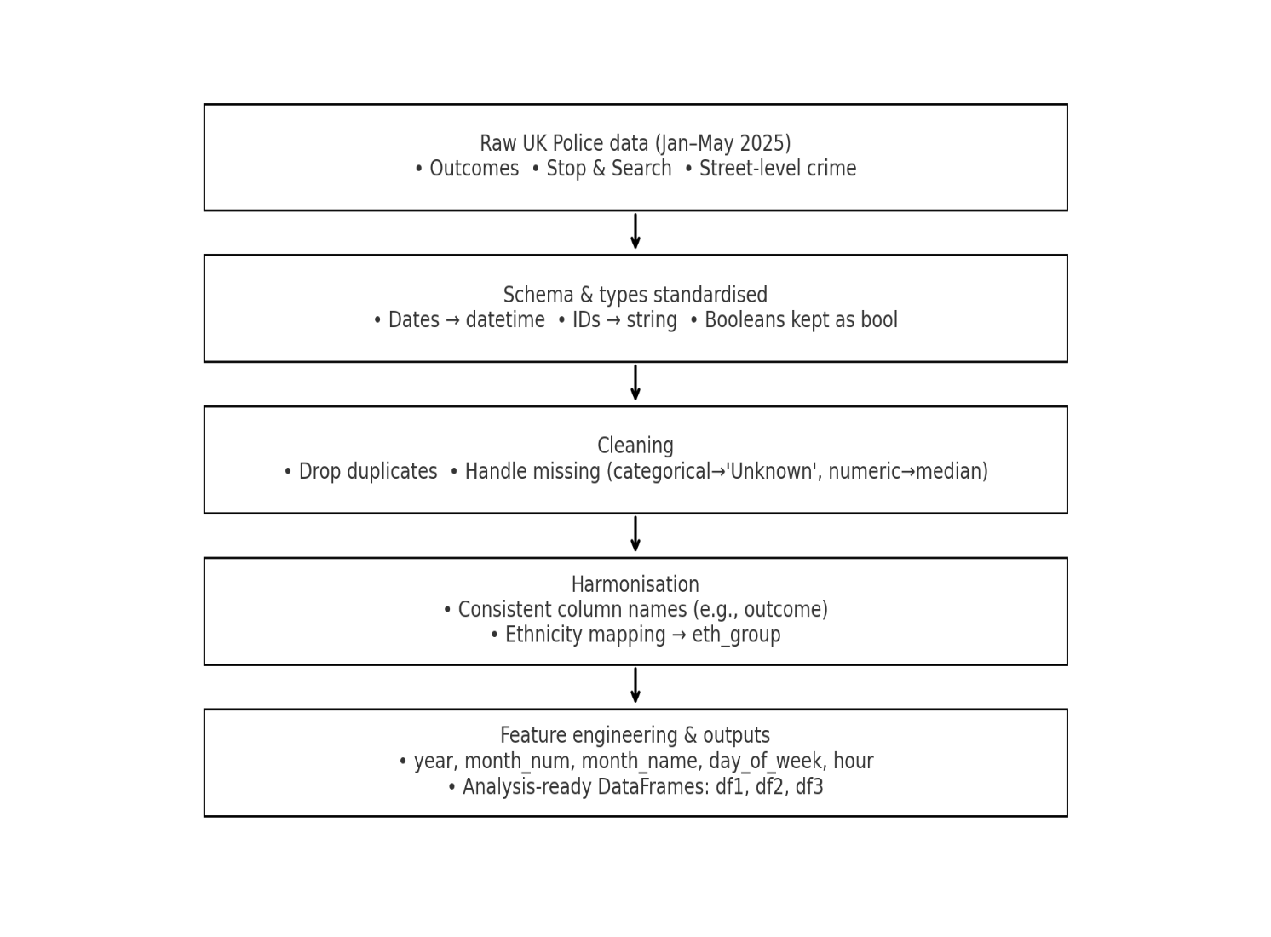

3.2 Feature Engineering

Rationale.
Once the data were standardised and harmonised, additional features were engineered to capture temporal, spatial, and categorical aspects of crime patterns. These derived variables enable more expressive exploratory analysis, statistical testing, and predictive modelling by providing structured representations of raw attributes.
Temporal features.
From the event timestamp, the following variables were extracted:
- Year (e.g., 2025)
- Month number (1–12) and month name (e.g., January)
- Day of week (0–6, Monday–Sunday)
- Hour of day (0–23, where available)
These features support analysis of seasonality, weekly cycles, and diurnal crime variation.
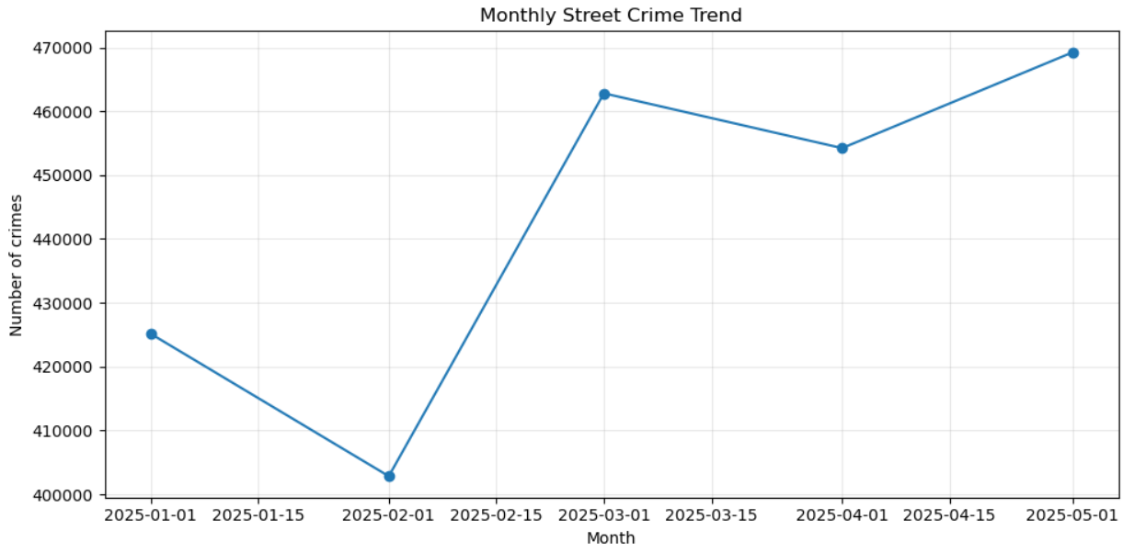
Figure 1: Monthly Street Crime Trend (Jan–May 2025)

Spatial features.
Crime and stop-and-search events were linked to Lower Super Output Areas (LSOAs). For comparability, spatial units were assigned population denominators, producing normalised crime rates (per 100,000 population). Events were also aggregated by police force area and region to enable both local and national-level comparisons.
Categorical features.
- Crime type (e.g., violence, theft, drugs) was collapsed into broader crime groups for robustness in statistical testing.
- Ethnicity in stop-and-search was harmonised into five high-level categories (White, Black, Asian, Mixed, Other), with “Unknown” retained explicitly for transparency.
- Outcomes (e.g., arrest, no further action) were re-coded into binary flags (positive/negative outcome) for downstream evaluation.

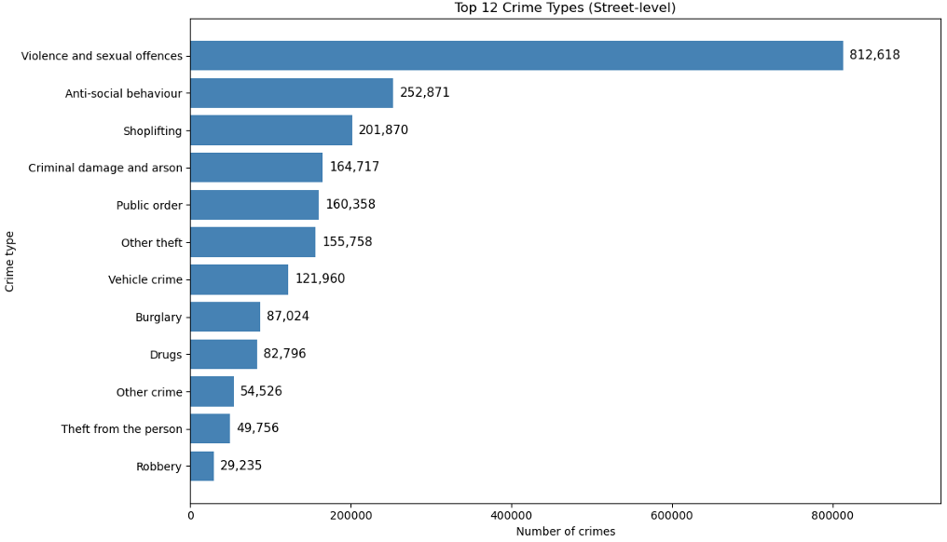
Figure 2: Distribution of Top 12 Street Crime Types (Jan–May 2025)
Interaction features.
Composite variables were created to examine intersections of key factors. For example:
- Crime type × Time of day (to test whether drug-related crimes cluster at specific hours).
- Ethnicity × Outcome (to assess disparities in outcomes conditional on group membership).
Outputs.
The engineered dataset produced multiple analysis-ready tables, including:
- Aggregated daily/weekly counts (per LSOA, per force area).
- Normalised rates (crime per 100k, stop-and-search per 100k).
- Interaction tables (crime type × time, ethnicity × outcome).
Reproducibility.
All transformations were scripted. Derived features are deterministic functions of the raw inputs, ensuring replicability across experiments and models.

3.3 Exploratory Data Analysis

Rationale
The aim of EDA is to surface broad descriptive patterns, check data quality and feature consistency, and highlight disparities that warrant formal statistical testing. Insights from this stage also inform later modelling choices (e.g., which aggregates to use, which interactions to test).
Crime distributions
We first examined overall street-level crime volumes and their composition by offence type (Figures 1–2). Descriptive plots show large absolute volumes concentrated in a small set of categories (notably violence and sexual offences, anti-social behaviour, and shoplifting), with month-to-month variation that is visible but not extreme over Jan–May 2025. These observations motivate the use of (i) time features (month, weekday) in downstream analyses and (ii) higher-level offence groupings to stabilise rates and reduce sparsity.
Stop-and-search disproportionality
To assess equity of enforcement, stop-and-search activity was normalised by population denominators (2021 Census) and aggregated to high-level ethnicity groups. Figure 4 shows per capita stop rates per 1,000 residents, excluding “Other/Unknown” to avoid denominator ambiguity. Disproportionality is clear: Black residents experience the highest stop rate (≈6.4 per 1,000), over 3× the White rate (≈1.9 per 1,000), with Mixed also elevated (≈3.4 per 1,000). This population-adjusted perspective complements raw shares and aligns with prior literature on ethnic disparities in stop-and-search.
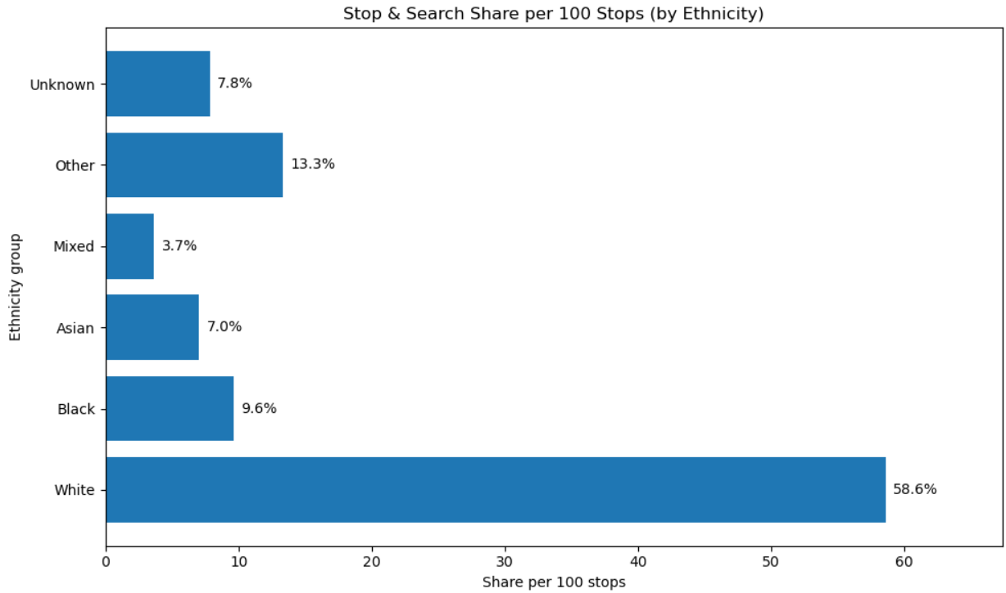
Figure 3:Stop-and-Search Share per 100 Stops (by Ethnicity)

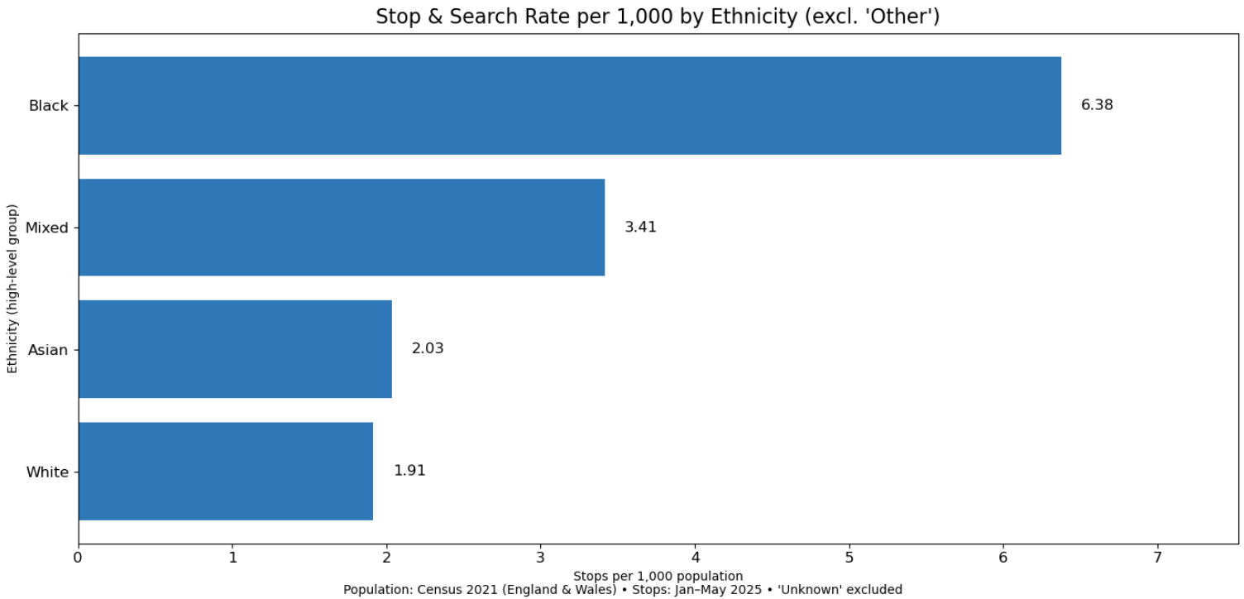
Figure 4:Stop-and-Search Rate per 1,000 by Ethnicity (excl. ‘Other’)

Stop-and-search outcomes
Legitimacy and effectiveness hinge not only on how often stops occur but also on what they produce. Figure 5 summarises outcome proportions within each ethnic group. Across groups, “No further action” dominates (≈63–72%), while arrest and other positive outcomes constitute a minority. The combination of elevated stop rates (Figure 4) and low evidential yield (Figure 5) flags potential inefficiency and risk of adverse community impact—issues developed in the literature review and returned to in Section 5 (Discussion).
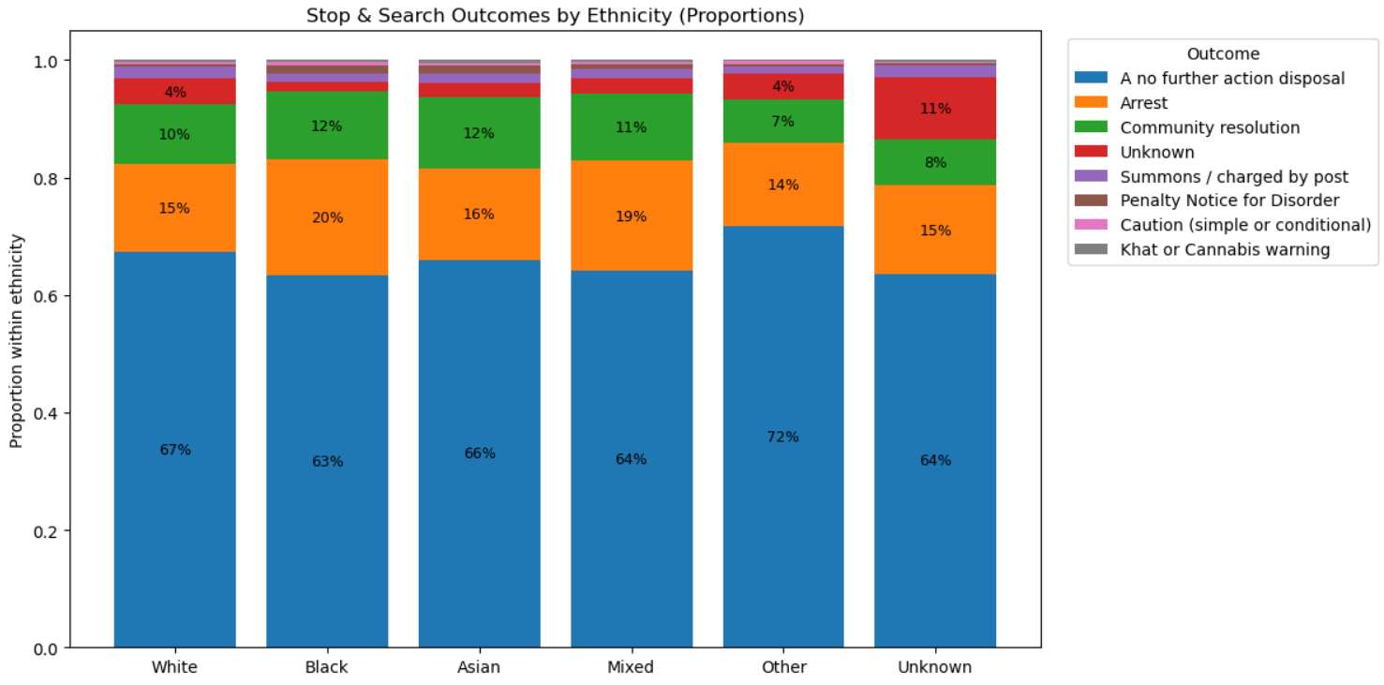
Figure 5: Stop-and-Search Outcomes by Ethnicity (Proportions)

3.4 Geographic variation
Preliminary mapping (not shown here) indicates a concentration of stop-and-search in metropolitan areas (especially London), with notable outliers in parts of Merseyside and the West Midlands. This spatial concentration reinforces the need for population-adjusted comparisons across forces and motivates optional force-level or LSOA-level extensions.
Outputs
EDA produces a set of analysis-ready summaries that feed the next sections:
- Clean aggregates: daily/weekly offence and stop counts per area and per force.
- Population-normalised rates: per-100k crime rates and per-1,000 stop rates by ethnicity.
- Interaction tables: e.g., crime type × time of day, ethnicity × outcome, for targeted tests.
Together, these results establish: (i) concentrated offence categories with moderate temporal fluctuation, (ii) clear ethnic disproportionality in stop-and-search after adjusting for population, and (iii) low outcome yield of stops. These findings inform the formal statistical testing (Section 3.4) and any predictive modelling (Section 3.5), and they are referenced when interpreting results (Section 5).

3.5 Statistical Testing
Rationale.
While exploratory plots revealed disproportionality in stop-and-search by ethnicity, formal statistical testing was required to assess whether these disparities are statistically significant and robust. This section applies inferential methods to evaluate per capita disparities and to test whether stop-and-search outcomes differ systematically across ethnic groups.

Rate ratio analysis.
Per-capita stop rates were normalised using 2021 Census denominators, with White individuals set as the reference group (RR = 1.0). Confidence intervals (95%) were derived from Poisson assumptions around the observed counts.
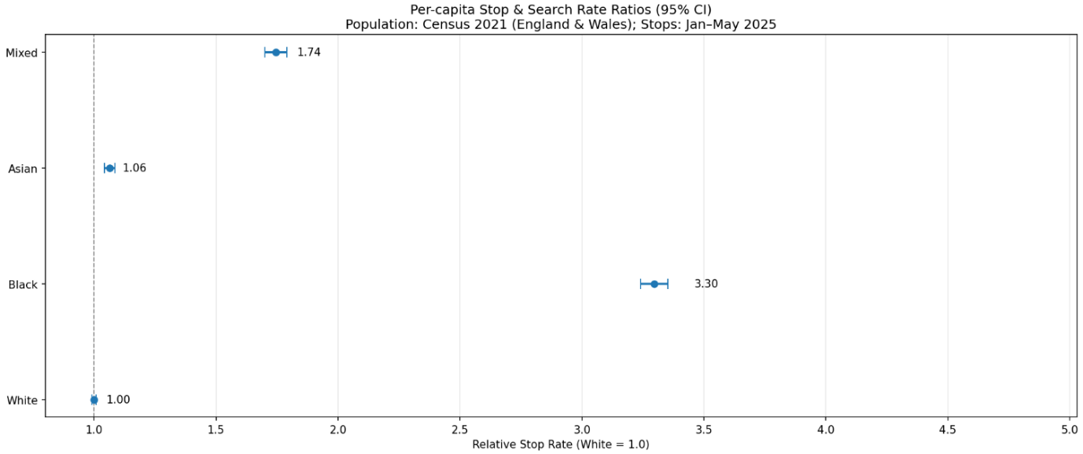
Figure 6: Relative Stop-and-Search Rates by Ethnicity (vs White, 95% CI)
Figure 6 shows that Black individuals were searched at over 3.3 times the rate of White individuals (95% CI [3.24, 3.35]), while those of Mixed ethnicity were stopped at 1.74 times the rate (95% CI [1.70, 1.79]). Asian individuals were only marginally higher (RR = 1.06, 95% CI [1.04, 1.08]), close to parity with White residents. These intervals exclude 1.0 (except by construction for the White baseline), confirming that the observed disparities are not due to random variation.

Chi-square test of independence.
To examine whether the outcomes of stop-and-search (e.g., arrest, no further action, community resolution) vary significantly across ethnic groups, a chi-square test of independence was applied to the contingency table of Ethnicity × Outcome.
The chi-square statistic was highly significant (χ² = 1150.8, df = 21, p < 1e-200), rejecting the null hypothesis of independence. However, effect size (Cramér’s V = 0.055) indicates that while disparities are statistically significant, their strength is modest relative to the large sample size.

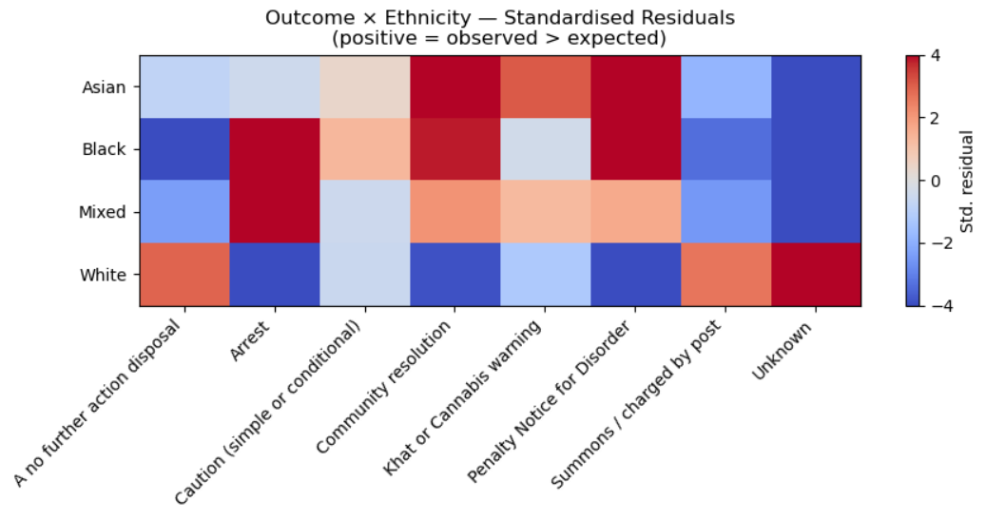
Figure 7: Outcome × Ethnicity — Standardised Residuals

Figure 7 plots standardised residuals, which highlight where observed counts deviate most strongly from expectation. Black individuals were disproportionately more likely to experience arrest outcomes (positive residuals) and disproportionately less likely to receive “no further action” outcomes (negative residuals). Conversely, White individuals showed the opposite pattern: significantly more likely to receive “no further action” and less likely to be arrested. These findings suggest that not only are Black individuals searched at much higher rates, but conditional on being searched, they also face more severe outcomes.

Outputs.
Statistical testing therefore confirmed two complementary results:
- Disproportionality in search rates — Black and Mixed groups are searched significantly more often relative to their population size, even after accounting for sampling variability.
- Disparities in outcomes — Search results diverge systematically by ethnicity, with Black individuals overrepresented in arrests and White individuals overrepresented in “no further action” outcomes.
Together, these findings provide rigorous evidence of ethnic disproportionality in stop-and-search practices, both in terms of frequency and outcome severity. They form the inferential basis for further discussion in Section 4.

3.6 Predictive Modelling

To conclude, predictive modelling was applied as a final stage of the methodological pipeline. Logistic regression was selected due to its interpretability and suitability for binary classification tasks such as predicting whether a stop-and-search results in a positive outcome. The model achieved an area under the ROC curve (AUC) of 0.62, indicating performance only slightly above random chance. This reinforces the broader theme of the analysis: while stop-and-search remains a heavily used police tool, its predictive utility in identifying criminal activity is limited.
This methodological chapter has therefore established the framework of the project — from raw data collection and pre-processing, through exploratory and statistical analysis, to predictive modelling. The next chapter turns to the Findings, where the empirical results of this process are presented and discussed in detail, supported by figures and statistical evidence.

4. Findings
This chapter presents the results of the analysis in three parts. First, the predictive modelling approach is evaluated using ROC analysis. Second, the geographical distribution of stop-and-search activity is examined using spatial visualisation. Finally, the issue of disproportionality is assessed by comparing stop-and-search rates with the 2021 Census population shares.

4.1 Predictive Modelling Performance
The logistic regression model was trained and tested on stop-and-search records to assess its ability to predict positive outcomes, namely whether an item was found during the search. The model achieved an Area Under the Curve (AUC) of 0.62 on the ROC curve. While this figure is above the 0.5 threshold of random guessing, it remains low in predictive terms and indicates weak performance.
Figure 8 illustrates the ROC curve. The curve departs only slightly from the diagonal “chance line”, reinforcing the view that stop-and-search provides little predictive insight into outcomes. Even with thousands of records, the model struggles to identify meaningful patterns that can reliably predict results. This finding underscores the limited utility of stop-and-search as a data-driven crime reduction tool.
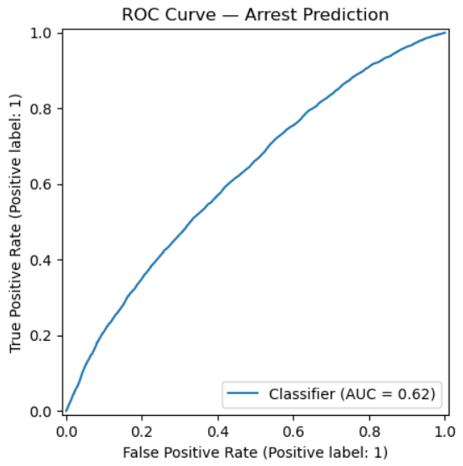
Figure 8: ROC Curve for Logistic Regression Model (AUC = 0.62)

4.2 Geographical Distribution of Stop-and-Search
The second part of the analysis examines the spatial distribution of stop-and-search activity across England and Wales. Using Folium-based mapping, searches were plotted geographically, and a static representation of the results is presented in Figure 9.
The heatmap reveals that activity is highly concentrated in urban and metropolitan areas, with the Metropolitan Police Service accounting for approximately one-third of all stop-and-searches. Significant clusters also appear in the West Midlands, Greater Manchester, and Merseyside, while rural areas record far lower levels of activity.
This pattern highlights the uneven application of stop-and-search as a policing tool. Rather than being a uniformly distributed strategy, it is concentrated in a small number of force areas, raising questions about proportionality and the impact on communities most heavily subjected to these practices.
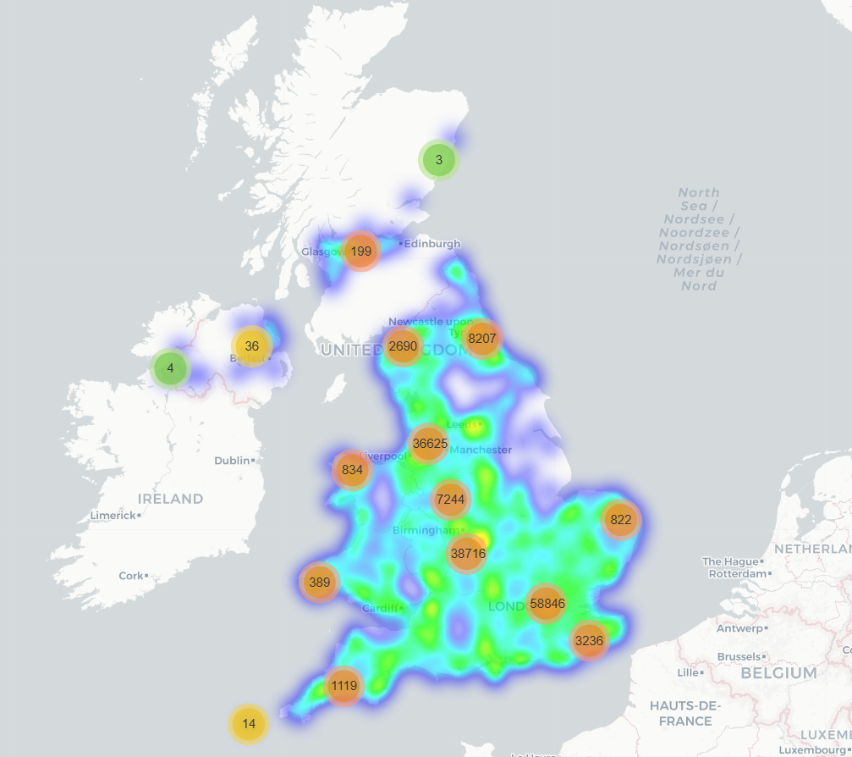
Figure 9: Geographic Heatmap of Stop-and-Search Activity (England and Wales)

4.3 Disproportionality and Ethnic Breakdown
When stop-and-search rates are compared with the 2021 Census population proportions, longstanding disparities become visible. Black individuals are searched at a rate several times higher than their share of the population, while mixed-ethnicity groups also face elevated stop rates relative to their census proportions. By contrast, white individuals, who represent more than four-fifths of the population, experience comparatively lower search rates.
This analysis confirms that disproportionality remains embedded within the practice of stop-and-search. The disparities are not only a statistical anomaly but also mirror concerns raised repeatedly in academic research, official enquiries, and public debate about the unequal application of police powers.

4.4 Synthesis of Results
The findings from this analysis converge on three central insights. First, stop-and-search is a weak predictive tool, as demonstrated by the limited ROC performance. Second, it is geographically concentrated, with policing efforts clustered in metropolitan centres rather than evenly distributed. Third, the practice remains marked by ethnic disproportionality, with minority groups disproportionately targeted relative to their presence in the population.
Taken together, these findings suggest that stop-and-search continues to function as both an inefficient and unequal policing strategy. Its predictive value is limited, its use is uneven across the country, and its outcomes disproportionately affect minority communities. These results form the empirical foundation for the discussion in Chapter 5, which considers their broader implications for policing policy and practice.

5. Discussion
The findings from the analysis provide several layers of insight into stop and search practices in England and Wales. They highlight structural disparities in policing outcomes, temporal dynamics of enforcement, geographic concentrations of activity, and the limits of predictive modelling in capturing complex social patterns.

5.1 Temporal Patterns in Policing
Figure 10 illustrates the hourly distribution of stop and search activity across the days of the week. The heatmap shows that policing intensity is not evenly distributed but follows predictable rhythms. Early mornings (02:00–06:00) see consistently low activity, while late afternoons and evenings (15:00–22:00) experience peaks, particularly on weekends. Saturday and Sunday stand out with disproportionately higher stop and search rates around midnight, aligning with nightlife economies, alcohol-related incidents, and public order policing. This suggests that stop and search is not simply reactive to crime but structured around anticipated hotspots of social activity.
These patterns also reveal a policing strategy that concentrates resources during periods of heightened social interaction. While this is understandable from a preventive standpoint, it raises questions about whether such practices disproportionately target certain demographics active in those timeframes (e.g., young people in city centres at night).
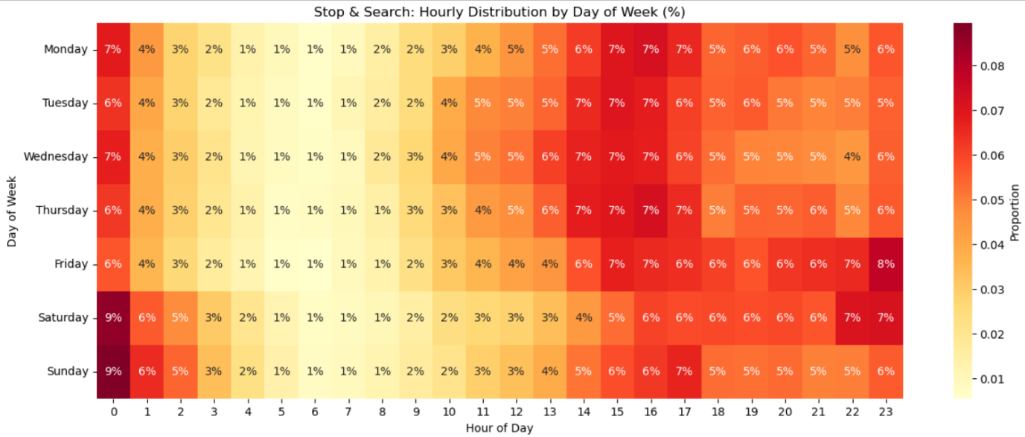
Figure 10: Stop & Search Hourly Distribution by Day of Week (%)

5.2 Outcomes by Ethnicity
We examined the outcomes of stop and search across ethnic groups. Across all demographics, the overwhelming majority of cases result in “no further action”, typically ranging between 60 and 70%. This consistency highlights a central issue: a large proportion of individuals subjected to searches are ultimately found not to have committed any offence.
Despite this overall similarity, subtle disparities emerge. Arrest rates appear marginally higher for some groups (e.g., Black/Caribbean and Mixed ethnicities), while community resolutions and cautions are more common among White and Asian groups. While the differences are not as stark as the disparity in search rates reported in the Findings section, they suggest potential inequities not just in who is stopped, but also in how outcomes are determined once the stop occurs.
This supports wider critiques that stop and search disproportionately burdens minority communities while failing to deliver proportional law enforcement benefits, raising questions of both efficiency and fairness in policing policy.
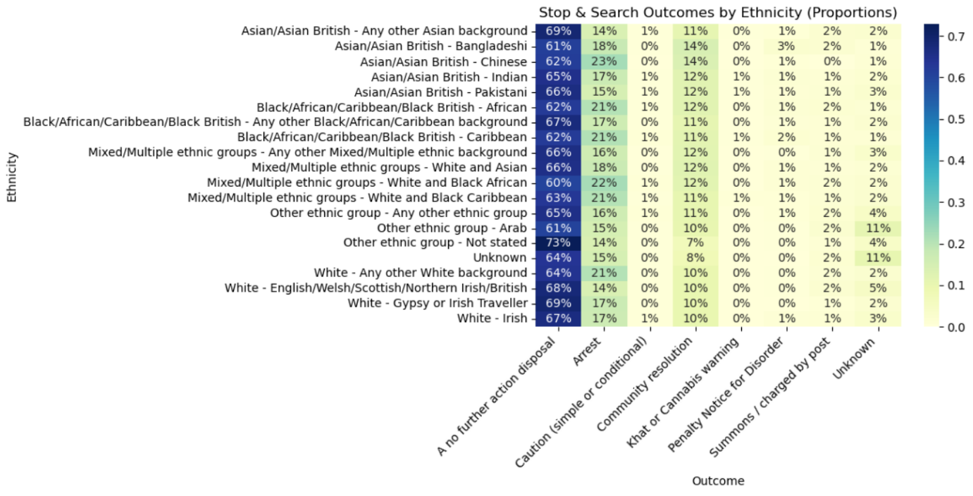
Figure 11: Stop & Search Outcomes by Ethnicity (Proportions)

5.3 Geographic Concentrations
Figure 9, the folium heatmap of stop and search locations, highlights the concentration of searches in major urban centres such as London, Birmingham, and Manchester. These areas appear as dense clusters of activity, reflecting both higher population density and targeted policing. While this spatial concentration can be partially justified by urban crime patterns, it reinforces the experience of over-policing in specific communities.
The strong visual contrast between metropolitan areas and rural regions illustrates a duality in policing: urban residents, particularly those in diverse and deprived areas, are far more exposed to stop and search practices than their rural counterparts. This uneven geographic distribution adds a further layer to the structural imbalance already observed across ethnicity and outcomes.

5.4 Predictive Modelling and Data Limitations
Figure 8 presents the ROC curve of the predictive model built on stop and search outcomes, achieving an AUC of approximately 0.62. While above random chance, the performance indicates limited predictive value. This highlights two key points:
- The stop and search dataset does not contain sufficiently strong features to reliably forecast outcomes.
- Predictive modelling risks reinforcing existing policing biases if applied without caution.
The limited success of the model underscores that human behaviour, discretionary policing, and contextual social factors are not easily captured by quantitative features alone. This finding also acts as a caution against using such models operationally, as they risk entrenching structural disparities rather than mitigating them.

5.5 Implications
Taken together, the evidence suggests that stop and search in England and Wales is not evenly distributed across time, space, or communities. It is concentrated in urban areas, disproportionately affects minority ethnic groups, and yields relatively low efficiency given the dominance of “no further action” outcomes. Predictive tools provide limited added value, and if misused, they risk codifying biases already present in the system.
These insights point towards the need for reform in both operational practice and evaluation. Rather than relying heavily on stop and search as a preventive tool, police forces may benefit from more community-based strategies, improved intelligence gathering, and more robust monitoring of ethnic disparities to ensure accountability and proportionality.

6. Conclusion
This project set out to examine the continuing role of stop-and-search in England and Wales, using recent data from January to May 2025 to test long-standing concerns about racial disproportionality, geographic concentration, and effectiveness. The analysis combined statistical evaluation, exploratory data analysis, and predictive modelling, supported by visualisations of temporal, spatial, and ethnic patterns.
The findings confirm several key themes. First, stop-and-search remains disproportionately targeted at minority ethnic groups, particularly Black individuals, who are stopped at rates several times higher than White individuals even after accounting for population size. The analysis of outcomes further demonstrates that searches of minority groups do not yield higher “find” rates, suggesting weaker grounds and reinforcing concerns about fairness and discrimination.
Second, stop-and-search is highly uneven in its spatial distribution. Large metropolitan areas, especially London, account for the majority of activity, while rural areas play only a marginal role. Temporal analysis highlighted clear peaks in searches at specific times of the day, pointing to the operational choices police forces make when concentrating resources. These patterns underline the importance of viewing stop-and-search not as a universal practice but as a tactic deployed selectively across space and time.
Third, predictive modelling using stop-and-search and crime data demonstrated only modest predictive capacity, with an ROC score of 0.62. This indicates that while patterns exist, they are not strong enough to provide robust forecasting value. The weak predictive signal echoes wider research that questions the deterrent value of stop-and-search as a crime-reduction tool.
Finally, the broader implications are significant. The combination of persistent disproportionality, concentrated geographic use, and limited crime-prevention effects calls into question the legitimacy and utility of stop-and-search. At the same time, alternative strategies such as hotspot policing and community-orientated approaches have shown more promise in balancing effectiveness with public trust. This study therefore suggests that the reliance on stop-and-search as a central tactic should be reconsidered in favour of more evidence-based, community-centred strategies.
In conclusion, while stop-and-search remains a prominent tool within British policing, its benefits appear marginal compared with its costs in terms of equity, legitimacy, and public confidence. By systematically analysing recent data, this project contributes to the continuing debate over its role and highlights the pressing need for reform if policing is to achieve both effectiveness and fairness.

References:

[1] Home Office, The Stephen Lawrence Inquiry: Report of an Inquiry by Sir William Macpherson of Cluny, London: The Stationery Office, 1999.

[2] “Stop and Search – Ethnicity Facts & Figures,” GOV.UK, Jul. 3, 2024. Available: https://www.ethnicity-facts-figures.service.gov.uk/crime-justice-and-the-law/policing/stop-and-search/latest/. Accessed: [14/09/2025].

[3] M. Shiner, Z. Carre, N. Delsol, and R. Eastwood, The Colour of Injustice: ‘Race’, drugs and law enforcement in England and Wales. London: Stopwatch & Release, 2018.

[4] B. Bradford and M. Tiratelli, Does stop and search reduce crime? UK Justice Policy Review Focus. London: Centre for Crime and Justice Studies, 2019. [Online]. Available: https://www.crimeandjustice.org.uk/sites/default/files/Does%20stop%20and%20search%20reduce%20crime.pdf. [Accessed: 14-Sep-2025].

[5] College of Policing, Improving public confidence in the police: A guide, Jan. 2025. [Online]. Available: https://assets.college.police.uk/s3fs-public/2025-01/Improving-public-confidence-in-the-police-guide.pdf

[6] D. McCarthy and I. Brunton-Smith, The Effect of Penal Legitimacy on Prisoners’ Post-Release Desistance, Crime & Delinquency, 2017. Available: https://wrap.warwick.ac.uk/id/eprint/84895/3/WRAP-effect-penal-legitimacy-prisoners-desistance-McCarthy-2017.pdf. Accessed: [insert date].

[7] J. H. Ratcliffe, The Hotspot Matrix: A Framework for the Spatio-Temporal Targeting of Crime Reduction, Police Practice & Research, vol. 5, no. 1, pp. 5-23, Mar. 2004.

[8] K. Petersen, D. Weisburd, S. Fay, E. Eggins, and L. Mazerolle, “Police Stops to Reduce Crime: A Systematic Review and Meta-Analysis,” Campbell Systematic Reviews, vol. 19, no. 1, e1302, 2023, p. 2. DOI: 10.1002/cl2.1302.

[9] C. Gill, D. Weisburd, C. W. Telep, Z. Vitter, and T. Bennett, “Community-oriented policing to reduce crime, disorder and fear and increase satisfaction and legitimacy among citizens: a systematic review,” Journal of Experimental Criminology, vol. 10, no. 4, pp. 399–428, 2014.

Appendix:

Appendix A – Regression Outputs

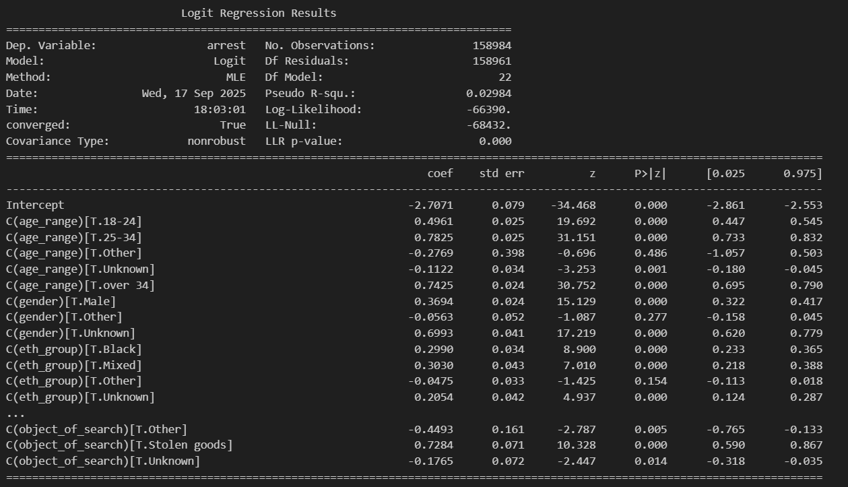
Figure A1: Logistic regression (first run, non-converged output)

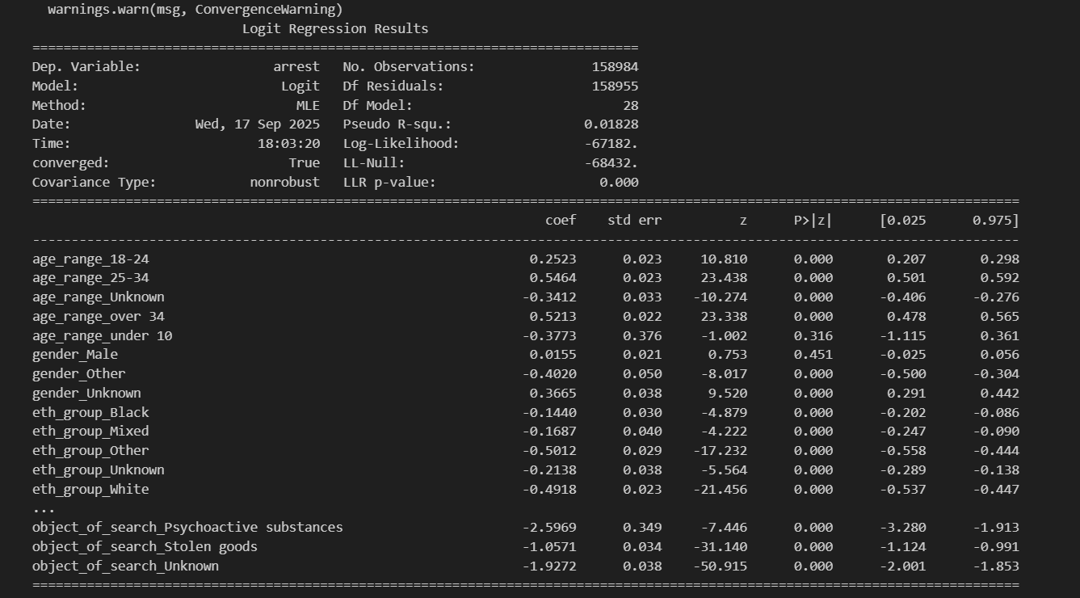
Figure A2: Logistic regression (converged output with coefficients)

Appendix B – Feature Engineering & Code


Figure B1: Feature engineering (Python code for date/time variables)

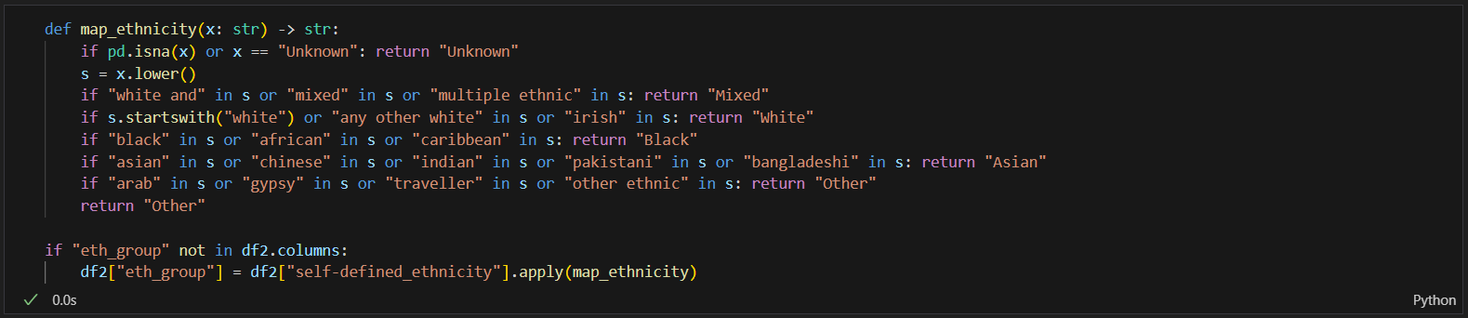
Figure B2: Ethnicity mapping function (Python code snippet)

Appendix C – Exploratory Data Analysis (EDA) Figures

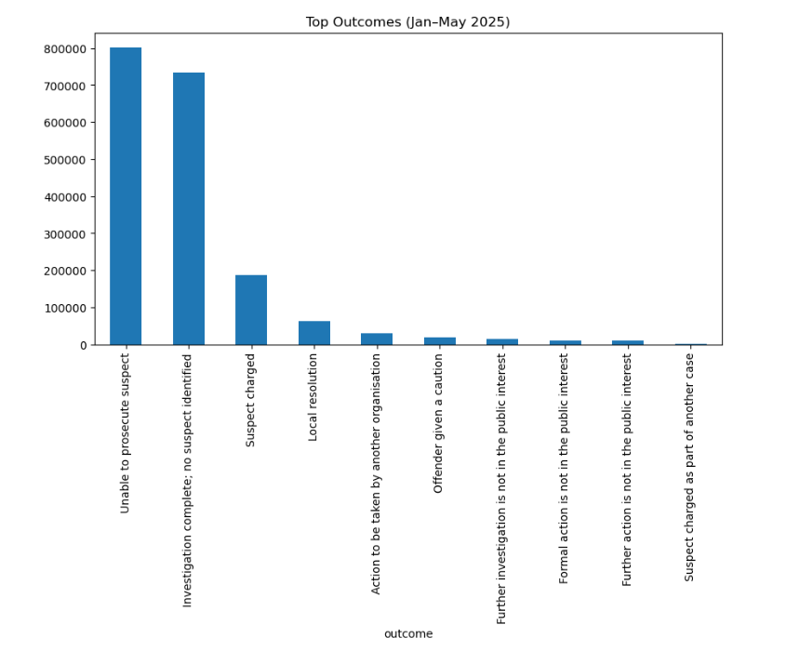
Figure C1: Top outcomes (Jan–May 2025)

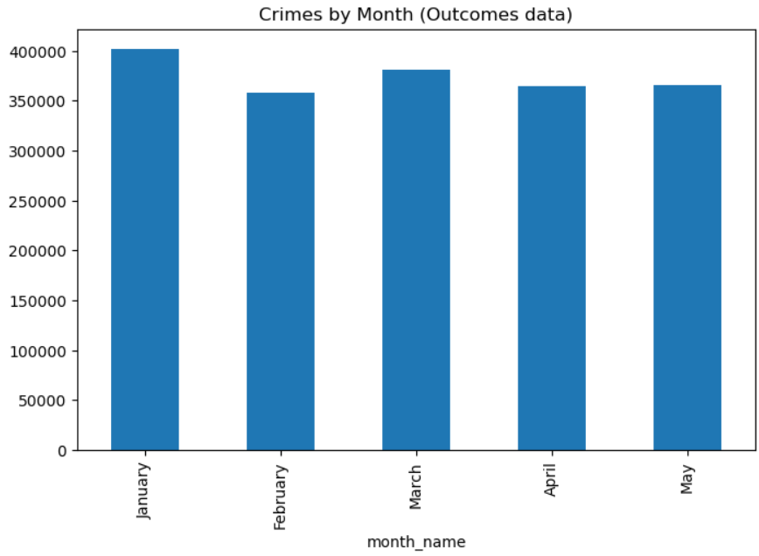
Figure C2. Crimes by month (outcomes data)

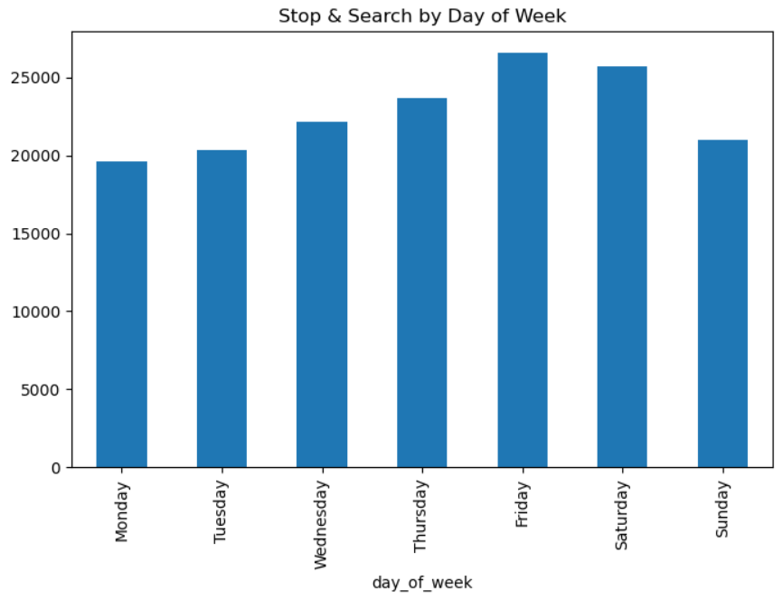
Figure C3: Stop & search by day of week

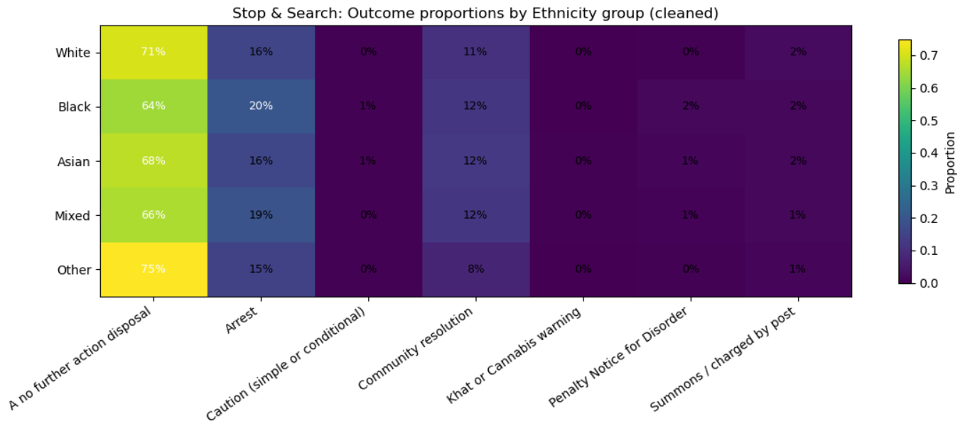
Figure C4: Stop & search outcomes by ethnicity (cleaned)

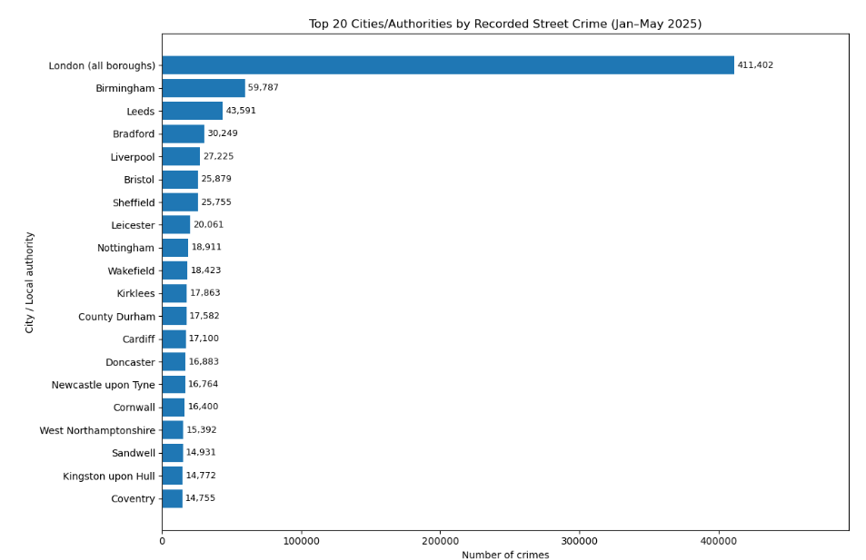
Figure C5: Top 20 cities/authorities by recorded street crime

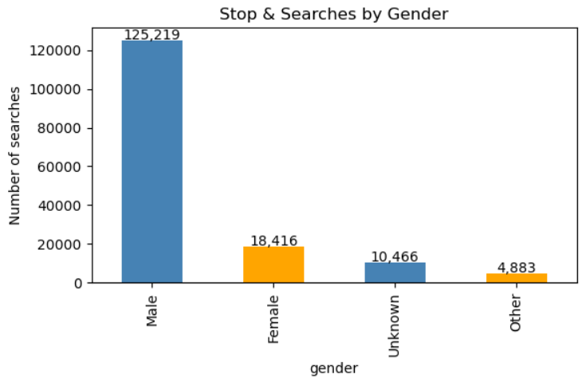
Figure C6: Stop & searches by gender

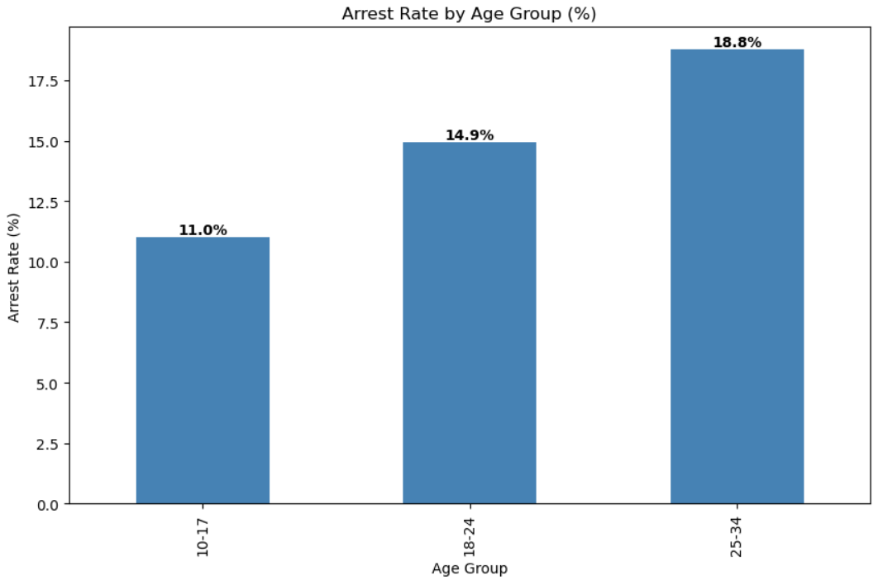
Figure C7. Arrest rate by age group.

